10-bit Potentiometric digital-to-analog convertor with off-chip external voltage reference

Bellana Avinash Naidu

Electronics and Instrumentation Engineering

National Institute of Rourkela, Odisha, India

avinashbellana@gmail.com

*Abstract- The paper proposes a potentiometric digital-to-analog convertor with an off-chip external reference voltage. The digital-to-analog converter is designed to achieve a 10-bit resolution. Several applications of the digital-to-analog converter have been listed down. A 2-bit potentiometric digital-to-analog converter has been designed using 180nm CMOS technology and simulated. Few parameters like offset voltage, DNL and INL are calculated.*

Keywords—DAC, potentiometer, off-chip, resolution, INL, resistor-string, voltage-scaling, CMOS, transmission gate, Inverter, DNL, Offset

# Introduction

The computer is undoubtedly the greatest invention of humankind. A computer works in a digital domain. In today's world, the existence of digital electronics is ubiquitous. Despite this, the world is yet analogous. Hence, there is a requirement for a bridge between these two domains, i.e., digital and analog. With the advent of high performance (especially in speed, power and area) digital circuits, the need for data converters with high speed and accuracy for a wide-ranging application has drawn the attention of scientists and researchers worldwide. This project aims at designing a 10-bit potentiometric digital-to-analog converter (DAC) with off-chip reference voltage given externally. The purpose of a DAC is reasonably straight forward. It converts a digital input to an analog output, which is a proportion of the reference voltage [1]. With proper design, DAC can reconstruct the sampled signal with precision. The output of a DAC may be voltage or current. Several parameters should be taken into account depending on the application it is used for. A DAC plays a vital role in a myriad of applications [4].

# DAC-terminology and basic design

The whole process of digital to analog conversion can be visualized as a mapping operation where a digital input (a combination of 0s and 1s) is mapped to a voltage value that depends on the reference voltage. In other words, the digital-to-analog conversion is the weighted sum of binary input combination. The simplest DAC is the kelvin divider or string DAC. String DAC is a chain connection of 2N resistors where N is the number of bits in the digital input. It consists of 2N switches with every resistor placed between each node of the chain and the output, and at a time, only one switch is closed to give the output [1]. One of the two ends of the chain is connected to a reference voltage, and the other is grounded. The digital input is given to the switches through an N-2N decoder. A slight change in this configuration results in a digital potentiometer (digit). In digipots, the grounded terminal of string DAC is connected to a voltage source rather than grounding, and they have one resistor less than the string DAC. A potentiometer is a three-terminal variable resistor that can be used as a voltage divider. A potentiometric DAC is also known as voltage scaling DAC. A digital potentiometer is a digitally controlled, three-terminal device, out of which there are two fixed end terminals at either end of the resistor chain and one wiper used to vary the output analog voltage. It is sometimes also known as resistive digital-to-analog convertor (RDAC).

Digital-to-analog converters are available as ICs or a part of microcontrollers. There are several specifications or features one has to take into account while selecting a DAC for an application. Several features like resolution, settling time, offset voltage, linearity should be considered. Resolution is the smallest detectable change in the output analog voltage. Resolution can be defined as the number of bits in the digital input or the step size. The project aims at designing a 10-bit potentiometric DAC, which means the resolution of this is 10-bits. A 10-bit DAC has 1024 steps. More is the number of bits, and better is the reconstruction of

the analog signal from the digital input. The other way of defining resolution is ‘step size’ given by the formula resolution = $Reference voltage/2^{N}$, where N is the number of bits. The resolution is multiplied with the gain factor in the presence of any amplifier at the output.

The characteristics of DAC depend on the reference voltage to a great extent. The reference voltage can be given internally or externally. In this proposed design, the reference voltage is given externally off-chip. The figure, Fig1 shows the basic design of a DAC. Two supply voltages VDD and VSS are provided. Here, the DAC is supplied by 3.3v and 1.8v source. Step size depends on the reference voltage. Another essential factor is the integral nonlinearity (INL). INL is defined as the deviation of the transfer function of the DAC with the ideal straight line measured in LSBs. High-end DAC has INL as low as 1 LSB. Similarly, offset voltage is defined as the output voltage when the digital input is 0. An offset can be compensated through calibration.

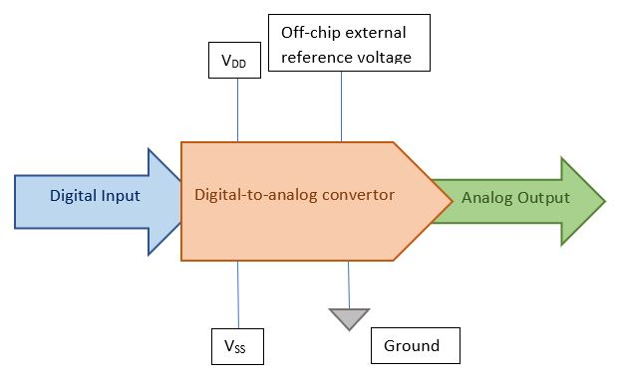

Fig 1 Block diagram of DAC

Another essential feature of a DAC is its settling time. No practical DAC gives the output as soon as the input is given to it [3]. There is always a delay in output. This time delay is called the settling time. Several other necessary specifications of a DAC are discussed in [3].

A 10-bit potentiometric or voltage-scaling digital-to-analog convertor [1] consists of a string or chain of 10 resisters, and each node of the chain is connected to a switch (mostly CMOS). Two voltage supplies are given at either end of the string. The proposed system has an off-chip voltage reference given externally. Off-chip means something that is not present on the IC or the chip directly. An ideal DAC is independent of environmental factors like temperature. But in a practical DAC, temperature causes the DAC to drift. The next section discusses few applications of a DAC.

# Applications of digital-to-analog converter

Digital-to-analog converters are used in a wide spectrum of applications. While IC manufacturers add several new features every year to microprocessor or FPGA, there will always be some type of analog conversion for interfaces. Therefore, a DAC plays a vital role in electronics industry. Depending on the application, a number of parameters like offset, gain, current bias has to be adjusted. This adjustment can be done manually or can be automated. The interaction with a mixed signal IC like DAC will be through an I2C compatible, SPI or Microwire serial interface. A voltage scaling DAC creates all possible values of the analog output and then makes use of a decoder to determine which voltage to select depending on the digital input word. The key attribute of a voltage scaling DAC is its guaranteed monotonicity and its compatibility with CMOS technology. Given below are few applications of a potentiometric or voltage-scaling DAC.

1. *In Mobile phones- for audio conversion*

The digital-to-analog converter is integrated in mobile phones to transform an audio signal in digital form to an analog audio signal. This is due to the known fact that we can’t hear digital audio and our mobiles are not capable of storing analog audio. So, a digital copy of the analog signal is made which is easier to be compressed and stored and similarly the digital is converted to analog when we want to play, for example, music. Thus, a DAC is essential. But before designing DAC for this purpose few parameters have to be taken into account for its suitability. They are size, power consumption, accuracy, speed, resolution and cost. The design consists of a resistor string DAC that includes a chain of resistors connected to switches. The switches are connected to an Opamp buffer through an analog multiplexer. The multiplexer selects voltage from the resistor string which acts as a voltage divider (potentiometric) depending on the digital input given. The multiplexer gives this voltage to the opamp buffer. This way the DAC converts the digital input to analog output. This is further sent to an amplifier to increase the magnitude of the signal. The amplifier then sends the analog audio to the speakers or headphones. Thus, a DAC is used to produce voltage gain with microcontroller commands. DAC is often incorporated into the entire audio system. The audio DAC is a low-frequency and high-resolution type DAC.

1. *Digital Radio Applications*

In digital radio systems, high speed digital-to-analog converters are required to allow advanced signal modulation.

The potentiometric DAC ensures guaranteed monotonicity and low temperature coefficient and is highly suitable for high speed applications. But a major disadvantage is its size which increases highly for just an increment of one in the resolution or the number of bits. The advantage with voltage-scaling DAC is the possibility to build multiple channel converter with the use of a single reference resistor chain. This saves the area and these DAC offer excellent differential linearity. DAC is also an integral part of software-defined radios. The main blocks of the DAC used for such applications are resistor chain, CMOS switches, output buffer and decoding network. Mobile communications require high-speed DACs and Optical communications require very high-speed DACs.

1. *Video processing*

Video encoder processes the video signal and gives the digital signal to various DACs which produce analog signals along with optimization. Video signals should be converted to analog signals if it is to be displayed on an analog display. With the advent of Flat panel displays along with DVI (Digital Visual Interface) and HDMI (High Definition Multimedia Interface), usage of digital inputs has become more and hence, a video DAC is essential for data conversion.

The DCA is desegregated with RAM (Random Access memory) which contains conversion tables for gamma correction and brightness to form a device called RAMDAC.

A Video DAC is a high-frequency DAC type with low-to-medium resolution.

Apart from these, DACs have many other applications. A DAC is also used to construct a digital potentiometer with some reorganization in resistors. Digipots are digitally controlled resistors. They are used to control an analog signal digitally. A resistor-string DAC is predominantly used for LCD column drivers. But large area for high resolution in RDACs has led to the proposal of other DAC architectures like CDAC and resistor-resistor-string DAC(RRDAC). With a microprocessor/microcontroller driving a DAC, a motor can also be controlled. The voltage-scaling digital-to-analog converters are fit for current digital CMOS processes. This is because they need very basic devices and have relaxed requirements for device matching.

##### References

1. Zumbahlen, H. (2007). *Basic linear design*. Analog Devices
2. United States patent.Patent no.: US6249239 B1. Patent date: June 19, 2001, Available: <https://patentimages.storage.googleapis.com/pdfs/7d0824ff6a551365cd24/EP1098441A3.pdf>
3. Digital-to-Analog Converters Are a "Bit - Maxim Integrated. Available: <https://www.maximintegrated.com/en/design/technical-documents/tutorials/1/1055.html>
4. J. J. Wikner and Nianxiong Tan, "Modeling of CMOS digital-to-analog converter for telecommunication," *in*IEEE Transactions on Circuits and Systems II: Analog and Digital Signal Processing*,* vol. 46, no. 5, pp. 489-499, May 1999, doi: 10.1109/82.769797.
5. F. Farah, M. El Alaoui, K. El Khadiri, H. Qjidaa and A. Lakhassassi, "A design of a new resistor string DAC for phones applications in 130nm technology," 2018 International Conference on Intelligent Systems and Computer Vision (ISCV), Fez, 2018, pp. 1-4, doi: 10.1109/ISACV.2018.8354063.
6. R. Wittmann, D. Bierbaum, W. Schardein and E. Matei,

"A parameterizable and process retargetable high speed DAC for digital radio applications," Twelfth Annual IEEE International ASIC/SOC Conference (Cat. No.99TH8454), Washington, DC, USA, 1999, pp. 404-408, doi: 10.1109/ASIC.1999.806543.

[7] Bridging the Divide: A DAC Applications Tutorial Available: <http://www.ti.com/lit/pdf/snaa129>.

[8] D. Liu, C. Lin, S. Yi and J. Chen, "A Resistor String DAC for Video Processing," Third International Conference on Intelligent Information Hiding and Multimedia Signal Processing (IIH-MSP 2007), Kaohsiung, 2007, pp. 503-506, doi: 10.1109/IIH-MSP.2007.56.

# 2-bit Potentiometric dac Cmos design and simuation

An N-bit version of a potentiometric DAC consists of a resistor-string with N equal resistors and 2N switches, one between each node of the chin and the output. The vital advantage of potentiometric digital-to-analog converter is its guaranteed monotonicity and its compatibility with the CMOS technology. But an increase in the number of bits results in a huge increase in the number of resistors and switches required and hence the area increases. Increase in N also results in a large parasitic capacitance at the output node resulting in slower conversion speeds. So, an alternating switching scheme is used that include multiple stages. The CMOS switches ensure that only one closed path exists for each digital input given.

A CMOS switch is an amalgamation of a transmission gate and an inverter. A transmission gate is a parallel connection of both PMOS and NMOS. A transmission gate is used instead of a simple NMOS or PMOS switch because of its capability to drive both logic ‘0’ and ‘1’ efficiently. Here, the channel length of both NMOS and PMOS is taken as 180nm but the widths are different. The width of each PMOS is taken as 900nm and that of NMOS as 360nm. The main reason for making PMOS larger than NMOS is that the rise time and fall time of gate should be equal and for this the resistance of the NMOS and PMOS should be same. Here, this is achieved by sizing the PMOS 2.5 times the size of NMOS.

In fig.1, D0 D1 is the digital input in binary form where D0 is LSB and D1 is MSB. Reference voltage (Vref) of 5v is given to the resistor string. VDD of 5v is given to each CMOS inverter. Piecewise linear voltage sources are used to give the digital inputs that vary with time. This is clearly shown in fig.2. An additional specification is considered i.e. maximum power dissipation of 5mV in order to find the resistance values.

$Imax=\frac{5mv}{5v}=1mA$; $R=\frac{5v}{4*1mA}=1.25kΩ$

The voltage at the tap associated with the ith resister should ideally be

$vi,ideal=i*vref/2^{N}$

As shown in fig.1, a transmission gate directs the analog voltage that corresponds to a bit pattern at the input to the output. At a time only one path is closed in the circuit that directs the analog voltage to the output node. The switching scheme used here ensures that there is no need of decoder. The numerical value of the analog output corresponding to digital input is given in table 1. The output for all 1s should be 1LSB less than the Vref.

$1 LSB=\frac{Vref}{4}=1.25v$

|  |  |  |
| --- | --- | --- |
| Digital input | Analog output (ideal)(volts) | Analog output (simulated)(volts) |
| 00 | 0 | 624m |
| 01 | 1.25 | 1.875 |
| 10 | 2.5 | 3.125 |
| 11 | 3.75 | 4.375 |

Table1.Digital input and the corresponding converted analog output (ideal and simulated).

Here, the output voltage for a digital input of 00 appears to be 624mv. This is called the offset error and it remains constant for all the input values and this can be compensated by calibrating the circuit. Eliminating this error or reducing it would make the simulated results to coincide with the ideal results i.e. for input 01, simulated output is 1.875v which includes the offset error, removing this 1.875-0.625v=1.25v which exactly coincides with the ideal analog output.

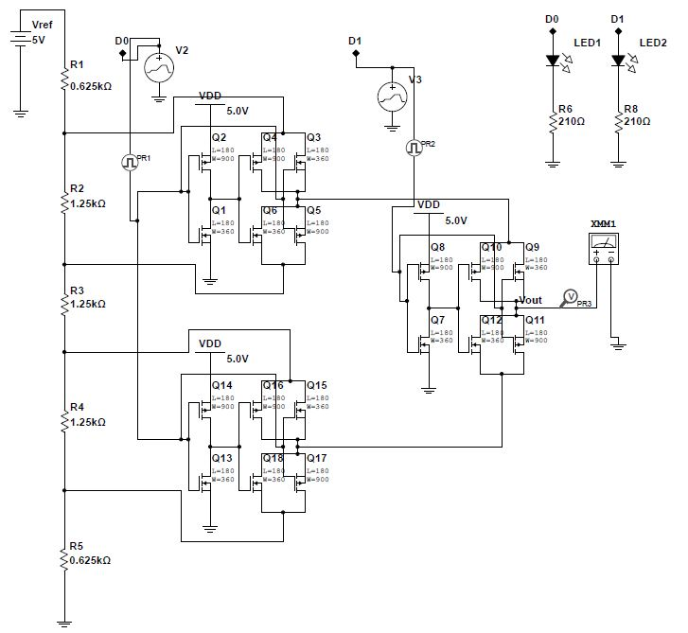

Fig.1. 2-bit potentiometric dac converter schematic.

The simulated input and output waveforms are shown in fig.2.

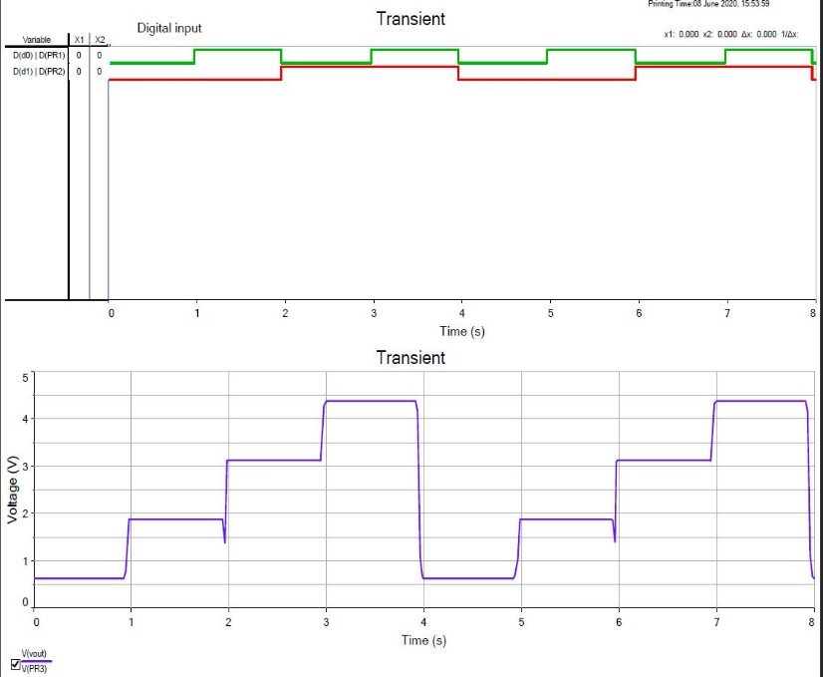

Fig.2. (top) Digital input(00,0,10,11); (bottom) analog output

The spice netlist is provided in the link below:

<https://drive.google.com/file/d/1SUjiEVchrPQ1zyA2JZZIyyEN4I1-IBIu/view?usp=sharing>

##### References

##### [1] Tingting Shi et al., "A low power and high precision DAC in 0.13µm CMOS for DVS system," 2010 International Conference on Communications, Circuits and Systems (ICCCAS), Chengdu, 2010, pp. 585-588, doi: 10.1109/ICCCAS.2010.5581929.